**Analysing the Impact of Dollarization and De-Dollarization  
on Foreign Export using Machine Learning**

**V. Manipriyaa, N. Mohanapriyab, D.Dafikc**

a, b PG and Research Department of Mathematics, Kongunadu Arts and Science College, Coimbatore, 641 029, Tamil Nadu, India

c Combinatorics and Graph, CGANT & Department of Mathematics Education,

University of Jember, Jember, Indonesia

E-mail: [mani310piya@gmail.com](mailto:mani310piya@gmail.com), [mohana_maths@kongunaducollege.ac.in](mailto:mohana_maths@kongunaducollege.ac.in), d.dafik@unej.ac.id

**Abstract**

In this paper we investigate the complex relationship between dollarization and Indian international exports over 07 years (2017- 2024). It delves into the US dollar’s dominant impact on Indian export performance. It analyses the effectiveness of the Indian government’s recent de-dollarization initiatives to reduce dependence on the USD and foster alternative trade mechanisms. The study draws upon country-wise export trade data to paint a comprehensive picture of Indian export flows across diverse market destinations. To extract deeper insights from this intricate data, the paper leverages the power of graph machine-learning models implemented within the MATLAB environment. This approach allows for analysing the interdependencies and hidden patterns within the export data, providing a more nuanced understanding of how dollarization and de-dollarization efforts influence Indian export performance.

Keywords: Rupees; Dollarization; De-Dollarization; India; Export; Graph Model.

**1.Introduction**

Graph theory, a branch of mathematics, provides a rigorous framework for understanding and modelling networks, the intricate webs of connections that underpin our world. In graph theory, entities or individuals are represented by nodes, and their relationships are denoted by edges. This conceptual framework enables the visualization, analysis, and modelling of complex systems, ranging from social networks [1] to transportation networks, and extending to the intricate world of international trade.

In the complex realm of international trade, the dynamics of dollarization [3] and de-dollarization [6] play pivotal roles in shaping economic landscapes. Graph theory, a powerful mathematical tool, emerges as an invaluable instrument for analysing these complex phenomena and their far-reaching impacts. This paper delves into the realm of graph theory, harnessing its capabilities to unravel the intricacies of dollarization and de-dollarization in the context of foreign trade economics. MATLAB was chosen for this work due to its powerful capabilities in the creation and manipulation of graphs [2], which serve as the foundational data structure for the analysis conducted.

**2. Preliminaries**

* **Nodes:** Nodes represent the objects in the system being model. They are represented by points or circles in diagrams.
* **Edges:** Edges represent the relationships between the objects. They are typically represented by lines or curves connecting the nodes.
* **Directed and Undirected Graphs:** In a Directed graph, edges have a direction, meaning that they have a starting point and an ending point. In an Undirected graph, edges do not have a direction.
* **Weighted and Unweighted Graphs:** In a weighted graph, edges have weights, which  
  represent the strength or cost of the connection between the nodes. In an unweighted graph, edges do not have weights.
* **Bipartite Graphs:** A bipartite graph is a graph in which the nodes can be divided into two sets, such that every edge connects a node in one set to a node in the other set.
* **International trading:** The exchange or trade of goods and services between different  
  nations.
* **Export:** Goods and services produced in one country but supplied to buyers in another are known as exports.
* **Currency:** Currency is a medium of exchange for goods and services.
* **Dollarization:** Dollarization refers to the widespread use of the US dollar as a medium of exchange, reserve currency, or unit of account in International trade and financial transactions.
* **De-Dollarization:** De-Dollarization refers to the process of reducing reliance on the US dollar in International trade and financial transactions.
* **Bilateral Agreement:** A bilateral contract is an agreement between two parties in which each side agrees to fulfil their side of the bargain.

**3. Dollarization**

In global trade, the dominance of the US dollar is profound. It goes beyond just preferring the dollar over local currencies; it fundamentally shapes how goods are traded worldwide. For example, products like Indian spices might be sold in US dollars to European buyers, and contracts for Venezuelan oil are settled using American currency. This illustrates the core concept of dollarization in global trade [3]. Imagine it as a coin with two sides. On one side, using the dollar offers stability and ease. Conducting transactions in USD simplifies international commerce, reducing currency exchange complications and aiding in financial settlements across borders. This can be advantageous for developing economies, attracting investments and strengthening trade relationships. However, there’s a downside. Heavy reliance on the dollar makes countries susceptible to changes in US monetary policies. A strong dollar can inflate export prices, affecting competitiveness on the global stage. Moreover, depending on a foreign currency limits a nation’s control over its own economy, impacting its ability to manage inflation and shape monetary policies. Dollarization levels vary widely across countries. Some, like Ecuador, extensively use the dollar, while others, like India, are working to promote their own currencies[8]. It’s not just about convenience versus control; it’s about finding a balance between leveraging the stability of the dollar and preserving economic independence. As global trade progresses, understanding the complexities of dollarization remains vital for nations aiming to succeed in the international market.

**4. De-Dollarization**

India is boldly stepping away from its reliance on the US dollar in global trade, a strategy known as de-dollarization [6]. This move aims to reduce India’s dependence on the dollar and strengthen the importance of its own currency, the Rupee. By doing so, India seeks greater control over its economy, aiming to minimize vulnerability to fluctuations in US economic policies that affect its exports and limit its ability to manage its economy independently, To achieve de-dollarization, India is actively promoting the use of the Rupee in international transactions. It’s forming agreements [9] with other nations to conduct trade deals in rupees instead of dollars. Additionally, diversifying its foreign exchange reserves by holding currencies other than the dollar, like Euros and Yuan, is part of its strategy to lessen reliance on the dollar’s dominance in global trade. However, this transition is not without its challenges. Building trust in the rupee as a global reserve currency takes time. There’s a need for significant improvements in infrastructure and legal frameworks to support this shift. India’s ongoing move away from the dollar demonstrates a determined effort to secure greater economic autonomy[7]. Whether the Rupee can significantly diminish the dollar’s importance remains uncertain, but India’s proactive approach challenges the prevailing economic norms and could potentially reshape the dynamics of global trade in the future.

**5. Data Source**

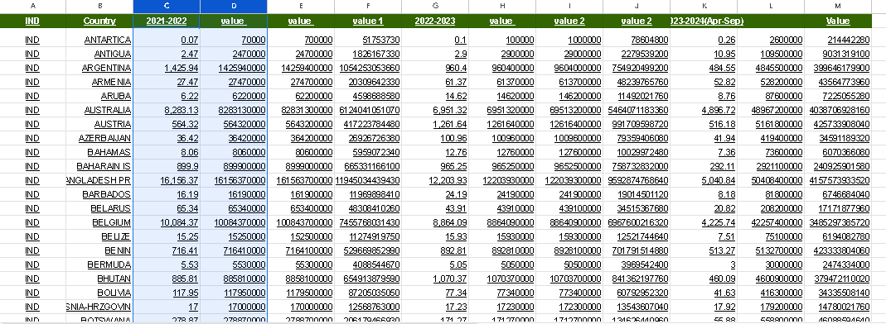For this study, we sourced the data from the official Indian government [GOVERNMENT OF INDIAMinistry of Commerce](https://tradestat.commerce.gov.in/eidb/default.asp). We utilized country-wise export data for both Dollars and Rupees. The dataset was conveniently available for download in Excel format, which proved more useful for comprehensive data analysis. The data was obtained directly from the official Indian government website, ensuring its authenticity and reliability. Utilizing country-wise import and export data in both Dollars and Rupees allowed for a comprehensive analysis of trade activities.

Figure 1: Data Set

**6. Modelling Data into a Graph**

**6.1 Data Preparation**

Firstly, the process commenced with Data Preparation. Trade data sourced from Excel  
spreadsheets underwent meticulous cleaning and uploading to the MATLAB environment. This critical phase ensured the data’s uniformity and precision, facilitating reliable analysis. Organizing the data into separable, categorized by both year and currency, streamlined subsequent operations.

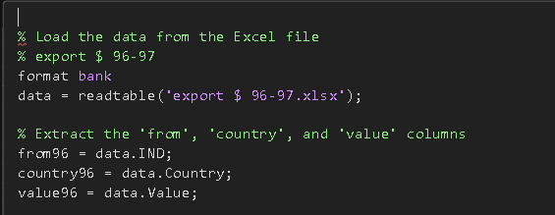

Figure 2: Data Uploding

**6.2 Graph Creation**

Subsequently, the Graph Creation ensued. For each specific year and currency, a weighted bipartite graph was generated using the versatile graph function. This process utilized the ’from’ and ’country’ columns to create nodes within the graph. The ’value’ column contributed to defining the edges’ weights, showing the trade values more precisely. Additionally, labels were assigned to nodes and edges, enhancing the graph’s clarity and facilitating easier identification.

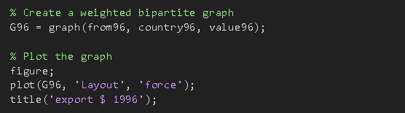

Figure 3: Graph Creation

**6.3 Adjacency list**

In addition to the graph creation described earlier, an alternative data structure used for  
efficient representation and analysis is the adjacency list. This structure maintains a list of connected edges for each node in the graph, including the destination node and associated weight. It offers advantages in terms of memory efficiency and specific analysis tasks compared to the adjacency matrix.

In our implementation, we created an adjacency list for each node in the graph, containing a list of connected edges with their respective destination nodes and edge weights. This facilitated efficient calculations of metrics such as betweenness, centrality and shortest paths, which are crucial for understanding the influence and connectivity of individual countries in the trade network. Furthermore, the adjacency list representation proved beneficial for analysing specific trade flows. By iterating through the list of edges for a selected node, we were able to identify its direct exports or imports and visualize the corresponding trade routes. This provided a detailed view of specific trade relationships and enabled the identification of key trade corridors.

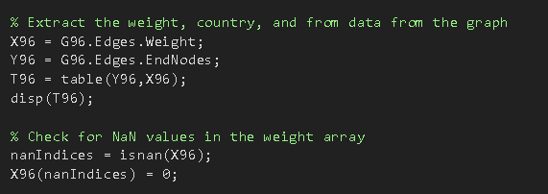

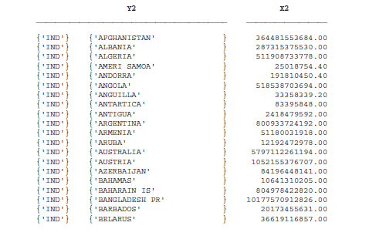Figure 4: Adjacent List

Figure 5: Adjacent List Sample

**6.4 Visualization**

The implementation phase progressed to Visualization, where the plot function, leveraging the force layout, was instrumental in graph visualization. This visualization technique offered insights into the intricate relationships between countries, illuminating potential clusters or communities within the trade network. The force layout’s dynamic depiction aided in comprehending the connections between nodes and identifying patterns or groupings that might exist within the trade landscape.

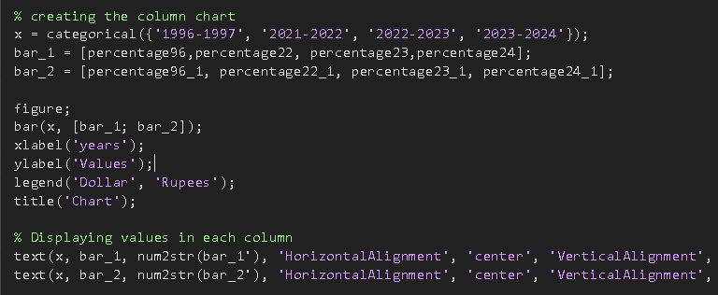

Figure 6: Visualization

**7. Result**

**7.1 Dollarization**

As we know after the Second World War the impact of the dollar on the global economy was abnormal and it is the same in the Indian economy too. After India got freedom India started to focus our international trade, In 1950 the GDP of India was hard to determine due to changing methodologies and inflation adjustments. However, estimates are around 133.7 billion rupees, and currently (2023) the GDP of India is 230 trillion rupees. Which has a growth of roughly 172,484% between 1952 and 2023. but at the same time, the impact of the dollar did not change.

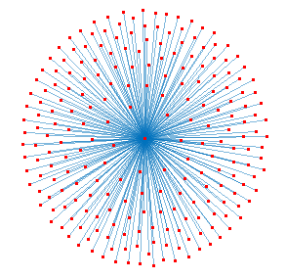The below Graphs deal with Indian International exports in 1950 for both USD and INR and compare the differences.

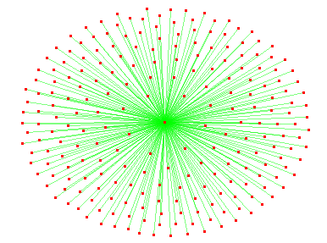

Figure 7: Export in $ 1996 Figure 8: Export in Rs. 1996

Our 90% of exports in 1950 were done using USD, the reliance on the dollar for international trade made India’s economy vulnerable to fluctuations in exchange rates. A stronger dollar meant Indian exports became more expensive for foreign buyers, impacting trade volume and earnings.

The below Graphs deal with Indian International exports in 2023 for both USD and INR and compare the differences.

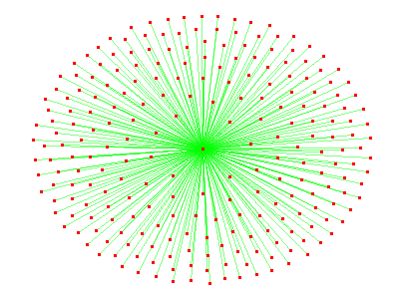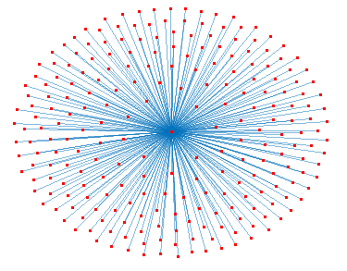

Figure 9: Export in $ 2023 Figure 10: Export in Rs. 2023

The fact that 90% of India’s exports were conducted in USD in both 1950 and 2023 is indeed striking. A stronger dollar still poses challenges for Indian exports, making them more expensive for foreign buyers and potentially leading to decreased trade volume and earnings. Despite India’s impressive economic growth, its international trade remains heavily reliant.

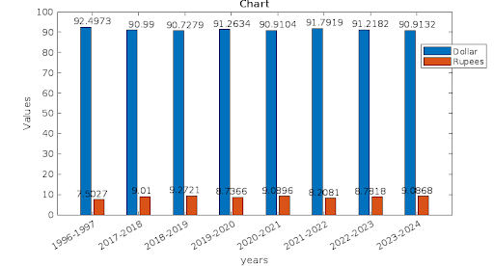

Figure 11: Result for Dollarization

on the USD. Surprisingly, the proportion of exports conducted in USD has remained remarkably consistent at around 90% between 2017 and 2023.This dependence on the USD exposes the Indian economy to the vulnerabilities of fluctuating exchange rates. A stronger dollar makes Indian exports more expensive for foreign buyers. This impedes India’s ability to fully capitalize on its potential for export growth. By remaining tied to a single currency, Indian exporters face an additional hurdle in competing with other countries in the global market.

7.2 De-Dollarization

Now 2023 India was the fifth largest economy country in the world the GDP was party  
dependency on the US Dollar was inevitable So the Indian government or plan to sign a bilateral agreement with their training partners to encourage trade in INR is a strategic move. By creating a framework for direct INR-INR settlements, these agreements can reduce conversion costs, and transaction risks associated with exchange rates, and potentially increase trade volume. Currently, India has signed 20 agreements with 20 countries some of which are the leading trading partners with India like United Arab Emirates (UAE), Mauritius, Sri Lanka etc.

The upcoming Graph says what if the trade between India and 20 countries was completely done by using INR.

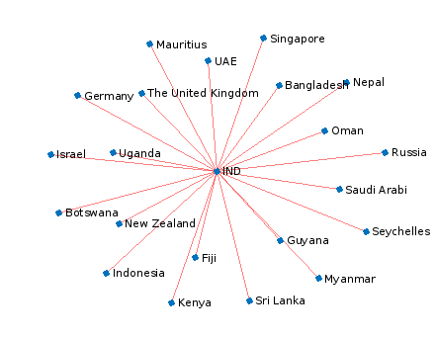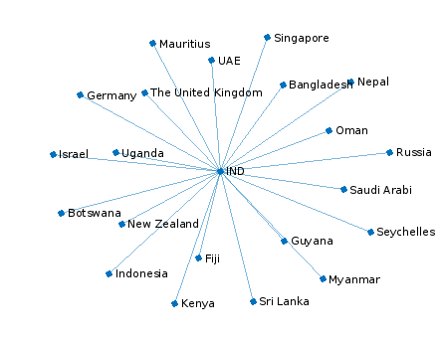

Figure 12: Export in $ 2023 Figure 13: Export in Rs. 2023

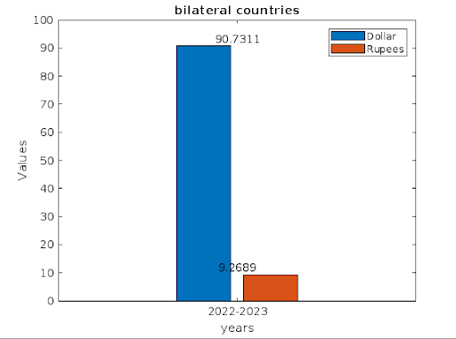

Figure 14: Result for De-dollarization

The current scenario shows the limited impact of the bilateral agreements, they represent a promising starting point for reducing India’s dependence on USD. Continued efforts to expand, incentivize, and streamline INR-based trade could eventually lead to significant economic benefits for India and its trading partners.

**8 Conclusion**

Despite substantial growth in GDP over the decades, the dominance of the dollar in India’s export transactions has remained remarkably consistent, hovering around 90%. This reliance exposes India to the fluctuations of the dollar, where a stronger dollar escalates the cost of Indian exports to foreign markets, potentially dampening trade volumes and earnings. This phenomenon highlights the need for a nuanced understanding of the impact of dollarization on India’s trade dynamics. India’s strategic shift towards bilateral agreements for INR-based trade signifies a proactive approach to mitigate the adverse effects of dollar dependency on its GDP. By fostering direct INR settlements, India aims to curtail conversion costs and transaction risks associated with fluctuating exchange rates. With 20 agreements already in place, including with key trading partners. India demonstrates its commitment to diversifying trade channels. However, to fully realize the potential benefits, sustained efforts are needed to expand and incentivize INR-based trade. As India solidifies its position as the fifth- largest economy globally, these strategic measures mark significant steps towards a more resilient and sustainable trade framework.

In conclusion, India has relied heavily on the US dollar in global trade, showing the importance of diversification. Now, India is making deals directly with other countries using its currency, the rupee, to lower risks and make its economy stronger. While these new agreements might not have big effects at first, they’re setting the stage for a stable and growing economy in the future. It’s crucial to keep pushing for more deals like this to protect against ups and downs in currency values and to build stronger connections with important trade partners.

**References**

[1] Abdul Majeed, Ibtisam Rauf, “Graph Theory: A Comprehensive Survey about Graph Theory Applications in Computer Science and Social Networks.” Inventions Publishing, vol. 5(1), pg. no. 10, 2020.

[2] Stamile, Claudio and Marzullo, Aldo and Deusebio, Enrico, “Graph Machine Learning: Take graph data to the next level by applying machine learning techniques and algorithms”, Packt Publishing Ltd, 2021.

[3] Kurt, Schuler, “Some Theory and History of Dollarization”, Cato J., vol. 25, pg. 115, 2005.

[4] Tomu, Lilian and Mutodi, Knowledge and Chuchu, Tinashe and Maziriri, Eugine Tafadzwa, “The Impact of Dollarization Policy on Zimbabwe Exports: A Gravity Model Approach”, International Journal of Economics and Financial Issues, vol. 11, no. 3, pg. 55, 2021.

[5] Jiahua, Zhang, “Research on De-dollarization and RMB Development in Central Asian  
Countries during 2010-2021”, Frontiers in Business, Economics and Management, vol. 5(3), 28-33, 2022.

[6] Pratik Patil, “stock market prediction using ensemble of graph theory, machine learning and deep learning models”, Master’s Thesis, Department of Computer Science, San Jose State University, 2019.

[7] Talwar, Huleppa, “the statuses of de-dollarization in the Indian economy”, JETIR, vol. 10(1), 326-332, 2023.

[8] Cohen, Benjamin, “Dollarization: pros and cons”, vol. 18, 2000.